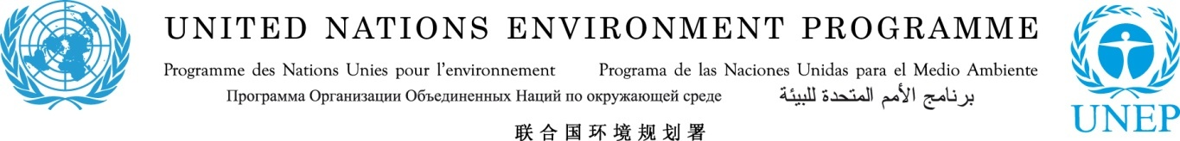

Policy Makers from Across Asia and the Pacific Meet at the
lites.asia Regional lighting Policy Workshop

Jakarta, Indonesia, 21 August 2014 – Policy makers from ministries of energy and environment, standards bodies, laboratories and industry organizations from 18 countries within Southeast Asia, South Asia, the Pacific and Europe met in Jakarta from 19-21 August for the United Nations Environment Programme (UNEP)/ lites.asia regional lighting policy workshop.
The meeting engaged almost 40 participants in building capacities for the development and strengthening of effective legislative frameworks for efficient lighting monitoring, verification and enforcement (MVE monitoring, verification and enforcement (MVE) systems. It also provided a discussion platform on the experiences, benefits and potential avenues for the development and harmonization of performance standards for efficient lighting products in the ASEAN region.
This workshop was hosted by the United Nations Environment Programme (UNEP) en.lighten initiative, the government of Australia and the Ministry of Energy and Mineral Resources of Indonesia. It was held as part of the Australian government sponsored “Securing the climate change benefits of efficient lighting in South East Asia and Pacific economies via monitoring, verification and enforcement capacity building activities” project which is being led by UNEP.
Presentations over the two days were delivered by the Indonesian Ministry of Energy and Mineral Resources, the Australian government, UNEP and UNEP partner countries, the ASEAN Centre for Energy, The Global Lighting Association, International Institute for Energy Conservation (IIEC), Global Efficient Lighting Centre (GELC), and the Chinese National Institute of Standards (CNIS).
At the workshop, the countries focused on experiences, benefits and potential avenues for the development and harmonization of standards and testing for efficient lighting products in Southeast Asia and the Pacific.
On the final day of the event, the government Research and Development Center for Electricity and Renewable Energy (P3TKEBT) hosted the delegates for a laboratory visit, allowing them to experience first-hand, lighting test laboratory conditions.
In an addition to the main programme, a workshop on 22 August was held specifically for Indonesian policy makers and industry representatives who explored the procedures and constraints for setting minimum energy performance standards and criteria for energy labelling.
###
CONTACT:Laura Fuller, Communications Officer, UNEP en.lighten initiative at laura.fuller@unep.org or by phone at +33 1 44 37 42 54

